



<Project Name>
Risk Management
Plan
Version <Enter Version #>

My signature indicates approval of this Risk Management Plan.
Prepared by:

Project Manager
Approved by:

Project Sponsor
Approved by:

Agency CIO

Table of Contents
1 Purpose 3
2 Risk PLanning Process 3
2.1 Risk Management Planning 3
2.2 Risk Identification Process 3
2.3 Risk Analysis 3
2.4 Risk Response Planning 3
2.5 Risk Monitor and Control 3
3 Risk Planning Detail 4
3.1 Methodology 4
3.2 Risk Roles and Responsibilities 4
3.3 Budget 5
3.4 Risk Management Activities 5
3.5 Risk Categories 6
3.6 Definitions of Risk Probability and Impact 6
3.7 Reporting 7
4 Issue Management 8
Attachment A: Department of Information Technology (DoIT) Risk Categories 9
Attachment B: Sample Risk Register 10

Revision History
Date | Version | Description | Author

<Template Overview and Instructions:
The Risk Management Plan describes how risk management will be conducted throughout the project. This plan is a required System Development Life Cycle (SDLC) deliverable for the SDLC Planning Phase. The Project Manager may periodically update the plan to improve upon risk management processes. Please refer to the Risk Management section of the SDLC Planning Phase methodology for an in-depth discussion of the risk management planning process. Instructional text in this document is bracketed and has a grey background. Other text may be used in your actual plan. Please remove the instructions when the document is finalized.>
- Purpose
<Describe the purpose and scope of the Risk Management Plan.>

The Risk Management Plan describes all planned processes and responsibilities to routinely perform risk identification, risk analysis, risk response planning, and risk control activities throughout the life cycle of the project.
- Risk PLanning Process
  - Risk Management Planning
<Address the goals, approach, and specific project artifacts and organizational policies the project team will use to conduct risk management activities.>
  - Risk Identification Process
<Risk is an uncertain event or condition that, if it occurs, has an effect on at least one project objective. Describe how the project team will identify risk and document risk characteristics in the form of risk statements (e.g., “EVENT may occur, causing IMPACT” or “If CAUSE, EVENT may occur, leading to EFFECT”). Identify the techniques the team will utilize to identify and characterize risks, for example, documentation reviews, team meetings, brainstorming, Delphi technique, interviewing, root cause analysis, historical analysis, assumption analysis, diagramming techniques, SWOT analysis, and expert judgment.>
  - Risk Analysis
<Discuss how the team will conduct qualitative risk analysis to prioritize risks and evaluate probability of occurrence and impact to cost, schedule, scope, and quality. An example is provided in Section 3.6 of this document. Describe how the team will ensure risk categorization consistency using a risk categorization schema such as the sample provided in Section 3.5 of this document.>
  - Risk Response Planning
<Describe how the project team will conduct risk response planning. Identify how the team will develop options and actions to reduce threats to and enhance opportunities for project objectives. Specify the high-level risk response strategies the team may employ (e.g., avoid, transfer, mitigate, or accept for threats or exploit, share, enhance, or accept for opportunities).>
  - Risk Monitor and Control
<Describe how the project team will conduct risk monitoring and control. Describe how the team will track identified risks and how the team will identify new risks. Although risks are identified during the Planning Phase, team members should continue to identify new risks throughout the duration of the project as part of risk monitoring and control. Detail how risk response owners will communicate risk status to the Project Manager and how the team will close outdated risks.>
- Risk Planning Detail
  - Methodology
<Describe the methodology to be used to manage project risk. See the Risk Management Plan section of the SDLC Planning Phase methodology for a discussion of risk planning.>
  - Risk Roles and Responsibilities
The Roles and Responsibilities table defines the lead, support, and other members who are responsible for risk management activities throughout the project life cycle. This list is role-specific; for the names of individuals assigned to these roles, please refer to the Project Management Plan.

Role | Responsibility
Project Manager | The role of the Project Manager is to write and approve the Risk Management Plan, define the risk management approach, participate in the risk management process, and take ownership of risk mitigation, planning, and execution.
Risk Officer | The Risk Officer is responsible for leading the risk management effort, sponsoring risk identification activities, facilitating communication throughout the execution of the risk management process, and ensuring the Risk Register is maintained and the statuses assigned to risks and risk activities are current. The Risk Officer is responsible for providing the Project Manager with recommendations and status regarding risk actions.
Executive Sponsor | The Agency executive who provides the financial resources and business authority for the project. The Executive Sponsor is informed of major risks and provides input to risk mitigation strategies.
Project Sponsor | The Project Sponsor is the business manager who is responsible for ensuring that the needs and accomplishments within the business area are widely known and understood and ensures that the design of the system meets both the functional and non-functional business goals. The Project Sponsor is informed of major risks and provides input to risk mitigation strategies.
<Identify role> | <Add description of responsibility here. Add rows as necessary.>
  - Budget
<Identify budgeted funds for risk mitigation activities for this project. Discuss the protocols for using contingency reserve.>
  - Risk Management Activities
<Specify risk management work to be included in the Work Breakdown Structure (WBS). Tasks 2.0 – 5.3 are typically repeated on a prescribed schedule throughout the project life cycle.>

The table below contains a list of risk planning related activities to be included in the overall project WBS.
ID | Risk Activity
1.0 | Risk Planning
1.1 | Define process, reporting, roles, responsibilities, and tools
1.2 | Forecast contingency budget for risk management
1.3 | Define risk management deliverables
1.4 | Complete Risk Management Plan
2.0 | Risk Identification
2.1 | Brainstorm risks
2.2 | Create baseline Risk Register
3.0 | Risk Analysis
3.1 | Evaluate risk and determine risk rating and prioritization
3.2 | Update the Risk Register with results of risk analysis
4.0 | Risk Response Planning
4.1 | Evaluate risk response alternatives
4.2 | Select risk response actions
4.3 | Assign responsibilities and schedule risk response actions
4.4 | Update the Risk Register with results of risk response planning
5.0 | Risk Monitoring and Control
5.1 | Conduct ongoing risk reviews
5.2 | Take corrective action
5.3 | Update the Risk Register
  - Risk Categories
<Describe the risk categories to be used to classify risks. Risk Categories represent a structure that ensures a comprehensive process of systematically identifying risks to a consistent level and value. This table represents a sample of potential categories that may be applied to each risk. This list is also displayed hierarchically in Attachment A: Risk Categories.>

Category | Sub-category
Technical | Scope Definition/Objective, Requirement Definition, Technical Process, Technology, Technical User/Interfaces, Technology Scaling, Performance, Reliability/Safety/Security, Testing
Management | Project Management, Resources, Communication, Interdependencies
Organizational | Culture, Sponsorship, Business Process, Acceptance, Supportability
Commercial | Contractual Terms and Conditions, Funding/Financial, Vendor Stability, Internal Procurement, Subcontractors, Applicable Laws, Contractor Experience
External | Legislative/Regulatory, Political, Pressure Groups, Weather, Force Majeure
  - Definitions of Risk Probability and Impact
<For the project, define the values and calculations to be used to quantify risk exposure. The table below represents one possible approach for analyzing risks. The probability and impact of risks to the project may be quantified according to the risk value in the table. The combination of the impact and probability will determine the risk value. Risk assessments are sometimes color-coded, and suggested values are listed below.>

Item | Definition | Risk Value
Probability | The probability of occurrence | 1, 2 or 3  (1 – Unlikely to occur  2 – May or may not occur  3 – Likely to occur)
Impact | The impact to the project objectives if the risk occurs. Refer to the Project Management Body of Knowledge, Section 11.1.3 for additional examples of impact definitions. | 1, 2 or 3  (1 – Minimal impact)  2 – Moderate impact)  3 – Significant impact)
Total Risk | The calculation of Probability times Impact | 1 through 9

Total Risk of 1-3 is low or green.
Total Risk of 4-6 is medium or yellow.
Total Risk of 7-9 is high or red.
  - Reporting
<Document the project risk reporting methods in the table below. The frequency of reporting will vary depending on the scope, size, and needs of the project. This information should be consistent with and documented in the Communication Management Plan.>

This table describes the frequency and format of how the project team will document, analyze, communicate, and escalate outcomes of the risk management processes.

Reporting Method | Description | Frequency
Risk Register | A document to report the results of risk identification, analysis, and response planning
Status Reports (optional)
Status Meetings (optional)
Steering Committee Meetings (optional)
Other Reporting Methods (optional)
- Issue Management
Project issues are related to risks in two ways: 1) unaddressed risks may become issues that adversely affect project performance, and 2) effective issue management minimizes project risk. <Describe the project’s issue management procedures. Identify the approach to identify, analyze, and manage project issues. Identify issue management roles and responsibilities. Describe how issues are raised, how issues are logged and tracked, how issues are evaluated and assigned for resolution, and how issue resolution actions will be executed. Address how triggered risks will be identified as issues and managed. Identify issue management tools, such as an Issue Log and project status reports.>

Attachment A: Department of Information Technology (DoIT) Risk Categories
This diagram details DoIT’s risk classification values and may be useful in categorizing project risks. The Project Manager may utilize this tool when developing the project Risk Register.
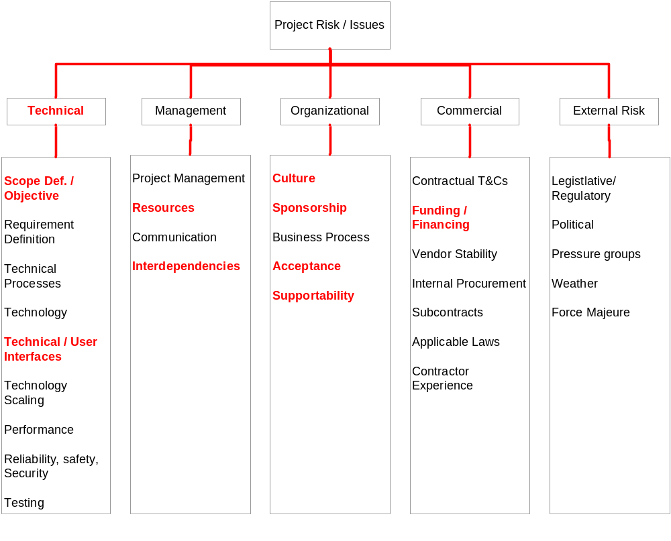

Attachment B: Sample Risk Register
The Risk Register captures the results of a qualitative and quantitative risk analysis and the results of planning for response.
Risk ID | Description | Category | Probability | Impact | Score | Risk Response | Status | Owner
Number | “Cause, Event, Effect” statement | Technical,  Management,  Organizational,  Commercial,  External | 1 - Unlikely  2 – May or may not occur  3 – Likely to occur | 1 - Minimal  2 - Moderate  3 - Significant | Product of Probability x  Impact  1-3 Green  4-6 Yellow  7-9 - Red | Watch,  Accept,  Transfer,  Mitigate,  Avoid | Open,  In Progress,  Resolved,  Closed | Team Member
1
2

